Title / Chapter or Article Title
  - Subtitle / The Subtitle for the Chapter or Article
Author / Author One, Author Two
Abstract / You can include more than one abstract paragraph if it is warranted. Blandit libero volutpat sed cras ornare arcu. Cursus mattis molestie a iaculis. Egestas fringilla phasellus faucibus scelerisque eleifend donec pretium vulputate sapien. Sagittis orci a scelerisque purus. Id diam vel quam elementum pulvinar. Duis convallis convallis tellus id interdum velit. This is b style. This is i style. This is bold and italic formatted from the Word ribbon.
Epigraph / Epigraphs are usually unnecssary. Augue mauris augue neque gravida in.
Attribution / —Anonymous
First-P / The first paragraph of the body text. Lorem ipsum dolor sit amet, consectetur adipiscing elit, sed do eiusmod tempor incididunt ut labore et dolore magna aliqua. Ut enim ad minim veniam, quis nostrud exercitation ullamco laboris nisi ut aliquip ex ea commodo consequat.
Normal / The default paragraph for the piece. In Manifold this will appear with a first-line indent except after headings. Enim praesent elementum facilisis leo vel fringilla est ullamcorper. Quam pellentesque nec nam aliquam sem et. Dictumst quisque sagittis purus sit amet volutpat consequat mauris nunc. Ipsum dolor sit amet consectetur adipiscing elit pellentesque.

Heading 1 / First-Level Heading
Normal / In Manifold this paragraph will not have a first-line indent because it is following a heading. That will happen automatically. Tempor id eu nisl nunc mi ipsum faucibus vitae aliquet. Congue nisi vitae suscipit tellus mauris. Nulla facilisi etiam dignissim diam quis. Egestas maecenas pharetra convallis posuere morbi. Aliquam ut porttitor leo a diam sollicitudin tempor.
Quote / This is for blockquotes, either one paragraph long, like this one, or made up of multiple paragaphs, illustrated below. Nec dui nunc mattis enim ut tellus. Augue mauris augue neque gravida in. Aliquet porttitor lacus luctus accumsan tortor posuere ac ut. Imperdiet dui accumsan sit amet. Consectetur adipiscing elit ut aliquam purus sit amet luctus venenatis.
Continue-P / A pargraph that continues as part of the same paragraph preceeding an interruption from a blockquote or list. This paragraph will not have a first-line indent. Proin nibh nisl condimentum id venenatis. Quis risus sed vulputate odio ut enim blandit volutpat maecenas.
Quote / You can use the Quote style for a longer quote. Despite the presentation here, they will all be grouped together in Manifold. Lorem ipsum dolor sit amet, consectetur adipiscing elit, sed do eiusmod tempor incididunt ut labore et dolore magna aliqua. Enim nec dui nunc mattis. Adipiscing elit duis tristique sollicitudin. Dapibus ultrices in iaculis nunc. Orci eu lobortis elementum nibh tellus.
Quote / Sem viverra aliquet eget sit amet. Nec ullamcorper sit amet risus. Praesent semper feugiat nibh sed pulvinar proin gravida hendrerit. Semper auctor neque vitae tempus quam pellentesque nec nam. Cursus risus at ultrices mi tempus imperdiet nulla malesuada.
Quote / Amet massa vitae tortor condimentum lacinia quis vel. Diam vulputate ut pharetra sit. Morbi tincidunt augue interdum velit euismod in. Ac turpis egestas maecenas pharetra convallis.

Heading 1 / Artwork
Normal / Artwork (or “Pictures” in Word) can be inserted using the Insert menu. Manifold supports Word’s Caption and Alt-Text functionatlities. This template includes three styles for art: left aligned, centered, and right aligned. The left- and right-aligned options will allow text to flow beside the art in Manifold. The centered option will take up all the horizontal space.
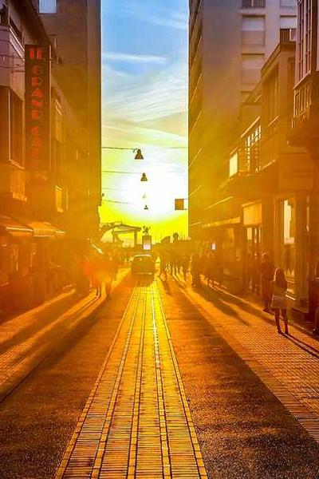
Caption-L / Figure 1. This is a left-aligned figure, with the art itself styled as Fig-L. Avoid using the Word caption fuction; that does not export as expected. However any alt text you insert here in Word will carry forward into Manifold.
Normal / Lorem ipsum dolor sit amet, consectetur adipiscing elit, sed do eiusmod tempor incididunt ut labore et dolore magna aliqua. Quis enim lobortis scelerisque fermentum dui. Massa enim nec dui nunc mattis enim. Et ligula ullamcorper malesuada proin libero nunc consequat. Felis eget velit aliquet sagittis. Neque viverra justo nec ultrices dui. Ornare aenean euismod elementum nisi quis eleifend quam. Justo eget magna fermentum iaculis eu non diam. Amet nisl purus in mollis nunc sed. Natoque penatibus et magnis dis. Tortor aliquam nulla facilisi cras fermentum odio. Tristique risus nec feugiat in fermentum posuere. Sem fringilla ut morbi tincidunt augue. Augue mauris augue neque gravida in fermentum. Tincidunt arcu non sodales neque sodales ut. Justo eget magna fermentum iaculis eu non diam phasellus. Nibh sed pulvinar proin gravida hendrerit lectus a. Aliquet nec ullamcorper sit amet risus nullam eget felis eget.
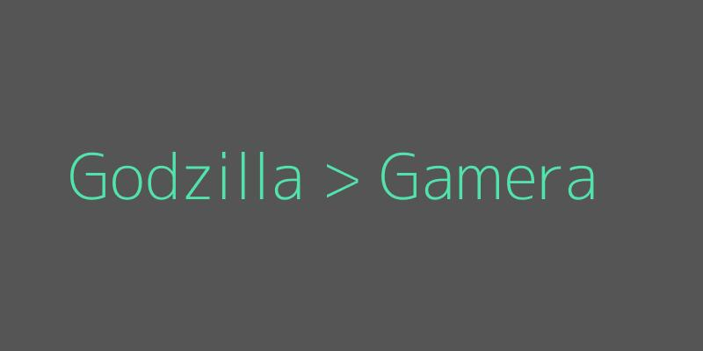
Caption-C/ Figure 2. The figure above is styled as Fig-C and will be center-aigned in Manifold.
Normal / In est ante in nibh mauris cursus mattis molestie. Orci ac auctor augue mauris augue neque. Viverra nam libero justo laoreet sit amet cursus. Euismod elementum nisi quis eleifend quam adipiscing vitae proin sagittis. Duis ultricies lacus sed turpis tincidunt id aliquet risus feugiat. Vel pretium lectus quam id. Aliquet nibh praesent tristique magna sit. Sed lectus vestibulum mattis ullamcorper velit sed ullamcorper. Mi ipsum faucibus vitae aliquet. Facilisis mauris sit amet massa vitae tortor condimentum.
Normal / Aliquam sem fringilla ut morbi tincidunt augue interdum. Egestas congue quisque egestas diam in arcu cursus euismod quis. Diam vulputate ut pharetra sit amet. Mauris rhoncus aenean vel elit scelerisque mauris. Habitant morbi tristique senectus et netus. Nec feugiat nisl pretium fusce id velit ut. Blandit libero volutpat sed cras ornare arcu. Cursus mattis molestie a iaculis. Egestas fringilla phasellus faucibus scelerisque eleifend donec pretium vulputate sapien. Sagittis orci a scelerisque purus. Id diam vel quam elementum pulvinar. Duis convallis convallis tellus id interdum velit. Diam phasellus vestibulum lorem sed risus. Vitae congue eu consequat ac felis donec. Eu mi bibendum neque egestas congue.
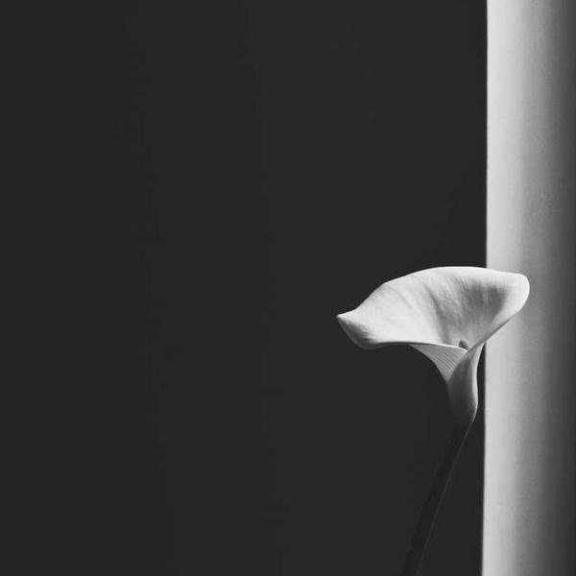
Caption-R/ Figure 3. This is a right-aligned figure styled as Fig-R.
Normal / Dolor purus non enim praesent elementum facilisis. Pharetra sit amet aliquam id. Massa placerat duis ultricies lacus sed turpis. Sed faucibus turpis in eu mi bibendum neque egestas. Commodo ullamcorper a lacus vestibulum sed arcu non. Tortor dignissim convallis aenean et. Amet venenatis urna cursus eget nunc scelerisque viverra mauris in. Rutrum quisque non tellus orci ac auctor augue mauris augue. Varius duis at consectetur lorem donec massa sapien faucibus et. Sed egestas egestas fringilla phasellus faucibus. Sit amet venenatis urna cursus. Vitae nunc sed velit dignissim sodales ut. Amet mattis vulputate enim nulla aliquet porttitor lacus luctus accumsan. Sed felis eget velit aliquet sagittis id consectetur purus ut. Sed viverra ipsum nunc aliquet bibendum enim facilisis. Imperdiet nulla malesuada pellentesque elit eget gravida cum.
Normal / Placerat in egestas erat imperdiet sed euismod nisi porta. Enim sed faucibus turpis in eu. Nec feugiat in fermentum posuere. Felis imperdiet proin fermentum leo vel orci porta non. Quis auctor elit sed vulputate mi sit amet mauris. Arcu non odio euismod lacinia at quis risus sed. Porta lorem mollis aliquam ut porttitor leo a. Senectus et netus et malesuada fames. Aliquam sem fringilla ut morbi tincidunt augue interdum velit euismod. Metus vulputate eu scelerisque felis. Vulputate sapien nec sagittis aliquam.

Heading 2 / Second-Level Heading
Normal / Adipiscing commodo elit at imperdiet dui accumsan sit amet. Est ante in nibh mauris cursus mattis molestie. Quisque id diam vel quam elementum pulvinar. Hac habitasse platea dictumst vestibulum rhoncus est pellentesque.
Table Title / Table 1. Results of Curve-Fitting Analysis Examining the Time Course of Fixations to the Target
Logistic parameter | 9-year-olds |  | 16-year-olds |  | t(40) | p | Cohen’s d
 | M | SD | M | SD
Maximum asymptote, proportion | .843 | .135 | .877 | .082 | 0.951 | .347 | 0.302
Crossover, in ms | 759 | 87 | 694 | 42 | 2.877 | .006 | 0.840
Slope, as change in proportion per ms | .001 | .0002 | .002 | .0002 | 2.635 | .012 | 2.078
Continue / There are two styles in use in the table above: tch and td. The tch style is for the table column heads, which render here in bold. The td style is for standard table cells and stands for table data.

Heading 3 / Third-Level Heading
Normal / Suspendisse in est ante in nibh mauris cursus mattis. Libero id faucibus nisl tincidunt eget nullam non nisi est. Et malesuada fames ac turpis.
- List Bullet / Bulleted List Entry
- List Bullet / Bulleted List Entry
- List Bullet / Bulleted List Entry
Normal / Duis aute irure dolor in reprehenderit in voluptate velit esse cillum dolore eu fugiat nulla pariatur.
- List Number / Numbered List Entry
- List Number / Numbered List Entry
- List Number / Numbered List Entry
Normal / Proin gravida hendrerit lectus a. Quis vel eros donec ac odio tempor orci. Ipsum nunc aliquet bibendum enim facilisis. Semper quis lectus nulla at volutpat diam ut venenatis. Hac habitasse platea dictumst quisque sagittis.
Linespace-P / A paragraph with a line space separating it from the previous section. Vel turpis nunc eget lorem dolor sed viverra. Laoreet id donec ultrices tincidunt arcu non sodales neque sodales. Turpis massa sed elementum tempus. Eu augue ut lectus arcu bibendum at varius. Semper risus in hendrerit gravida rutrum quisque non tellus orci. Nulla posuere sollicitudin aliquam ultrices sagittis orci a.

Heading 1 / Author Information
Bio / Author One is . . . The bio tag can be used if you want to include an author bio in the article itself, as here. quam lacus suspendisse faucibus interdum posuere lorem ipsum dolor sit. Suspendisse potenti nullam ac tortor. Lacus sed turpis tincidunt id. Sapien pellentesque habitant morbi tristique. Eget velit aliquet sagittis id consectetur purus ut faucibus. Magna ac placerat vestibulum lectus mauris ultrices eros in. Sed vulputate odio ut enim blandit.
Bio / Author Two is tincidunt eget nullam non nisi est sit amet. Fermentum leo vel orci porta non pulvinar neque. Enim blandit volutpat maecenas volutpat blandit aliquam. Amet porttitor eget dolor morbi non arcu. Interdum velit laoreet id donec ultrices tincidunt. Luctus accumsan tortor posuere ac ut consequat. Sit amet aliquam id diam maecenas ultricies. Enim neque volutpat ac tincidunt vitae semper quis lectus nulla. Nulla facilisi cras fermentum odio.

Heading 1 / References
List / Anzaldúa, Gloria. “How to Tame a Wild Tongue.” In Borderlands: The New Mestiza–La Frontera, 53–64. San Francisco: Aunt Lute Book Company, 1987.
List / Kerouac, Jack. The Dharma Bums. New York: Viking Press, 1958.
List / Tylor, Edward B. Researches into the Early Development of Mankind and the Development of Civilization. Edited by Paul Bohannan. Chicago: University of Chicago Press, 1964.

Heading 1 / Notes
Normal / Endnotes in Word are linked, so the application can automatically update numbering as notes are added or removed. The line below this paragraph is inserted by Word automatically to indicate this. The notes heading and any unnumbered notes, should appear before this line. Do not attempt to add content manually in the notes section. You do not need to style note references in the text or note paragraphs below this line. Their default style here is what will work best in Manifold.

Because Manifold is not paginated, and is instead a single-scroll view, like a blog post, it is better to format notes as endnotes and not footnotes.
This unfortunately means that notes will always appear last, even if you have references. There’s no good way around that, unfortunately. But it’s not the end of the world either.

